Category 6 Connection Box

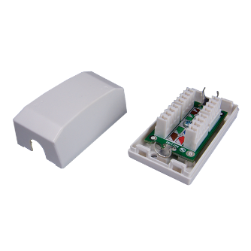

Female to female in-line coupler offer two types - cable extension type and panel mount type, compact housing and great performance. Panel mount type can be used with series I flush mount wall plates

Ordering Information

|  |  |
| --- | --- |
| PART | Description |
| SJ01P600-XX | Cat.6 KRONE/110 IDC connection box, Unshielded |
| SJ01P6S0 | Cat.6 KRONE/110 IDC connection box, Shielded |

"XX" = color. white (WH), ivory (IV).